
Abl (Y253H)
Catalog Number: CR-M26154
Gene Symbol: ABL1; ABL; JTK7; bcr-abl; c-ABL; p150; v-abl
Description: Anti-Abl (Y253H) Mouse Monoclonal Antibody

Background: V-abl Abelson murine leukemia viral oncogene homolog 1 also known as ABL1, is a cytoplasmic and nuclear protein tyrosine
kinase that has been implicated in processes of cell differentiation, cell division, cell adhesion, stress response and cell migration. Deficient in Abl can cause severe disease such as leukemia.
Immunogen: A synthetic peptide from the internal region of Abl which includes the mutation of Y253H, human origin.
Tested applications: ELISA, WB, IHC Recommended dilutions:
ELISA: 1:1000-1:5000
WB: 1:100-1:1000
IHC: 1:50-1:100
Concentration: 1 mg/ml
Host: Mouse
Clonality: Monoclonal
Purity: Purified from ascites
Format: Liquid Storage buffer:
Preservative: no
Constituents: PBS (without Mg2+ and Ca2+), pH 7.4, 150 mM NaCl, 50% glycerol
Species Reactivity: recognizes Y253H mutated, but not wildtype of vertebrates.
Storage Conditions: Store at -20°C. Avoid freeze / thaw cycles.

Western blot:
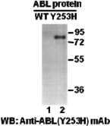
Western blot analysis of recombinant Abl
(Y253H) and wildtype proteins. Purified
His-tagged Abl (Y253H) protein (amino acids
1-76, lane 2) and corresponding wild type protein (lane 1) were blotted with anti-Abl (Y253H)
mouse monoclonal antibody (Cat. #26154).

For research use only. Not for diagnostic or therapeutic applications.

Immunofluorescence:
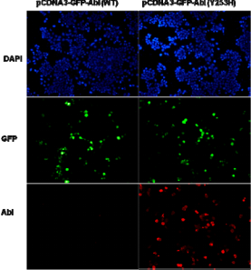
Immunofluorescence of cells expressing Abl proteins with anti-Abl (Y253H) antibody.
HEK293T cells were transfected with
pCDNA3-GFP-Abl (WT) plasmid (left column) or pCDNA3-GFP-Abl (Y253H) plasmid (right column), then fixed and stained with anti-Abl (Y253H) monoclonal antibody (Cat. #26154).

